Imagine a warehouse has an FX9600 at the exit gate. Every carton has an RFID tag. The business wants three things: read cartons, monitor reader health, and control/configure the reader remotely.
The overall flow is:
RFID Tag
↓
RFID Radio
↓
Radio Control
↓
Reader Gateway
↓
MQTT / REST / HTTP
↓
Cloud or Local Application
Now let us map each part.

Management Interface
Suppose the administrator wants to change reader settings.
Example:
"Change the reader configuration."
or:
"Update the firmware."
The application sends a request:
Application
↓
Management Interface
↓
Reader Gateway
↓
Reader Manager
↓
Configuration is changed
Then the reader sends a response:
Request:
Set configuration

Response:
Configuration updated successfully
That is why it is called synchronous.
Think:
Request → Response
So:
Management Interface = configure and manage the reader itself.
Typical examples:
Get configuration
Set configuration
Firmware update
Network configuration
Application configuration

Management Events Interface
Now imagine nobody asks the reader anything.
But suddenly the reader CPU becomes very high.
The reader itself sends:
WARNING:
CPU utilization = 95%
Or every 60 seconds it sends:
Heartbeat

Temperature: 45°C
CPU: 35%
RAM: 52%
Status: Healthy
Nobody requested it.
That is why this is asynchronous.
Reader
↓
event happens
↓
Reader automatically sends event
↓
Application
So:
Management Events Interface = the reader proactively reports health, status, warnings, errors, GPIO events, and heartbeat information.
The difference is very important:
Management Interface
Application asks → Reader responds

Management Events Interface
Reader sends → without application asking

Control Interface
Now the warehouse operator wants to start reading cartons.
The application sends:
START RFID READING
The flow is:
Application
↓
Control Interface
↓
Reader Gateway
↓
Radio Control
↓
RFID Radio starts scanning
Later:
STOP RFID READING
or:
Change RFID mode
So:
Control Interface = controls the RFID-reading operation.
A simple way to separate Management and Control is:
Management
= configure the reader

Control
= tell the RFID operation what to do
For example:
Management:
Configure MQTT broker

Control:
Start inventory

Data Interface
Now the antenna detects a carton.
Suppose it reads:
EPC: BOX123
Antenna: 2
RSSI: -46
Timestamp: 10:30:20
The flow becomes:
RFID Tag
↓
RFID Radio
↓
Radio Control
↓
Reader Gateway
↓
Data Interface
↓
MQTT / HTTP
↓
Warehouse Application
So:
Data Interface = sends RFID tag-read information to external applications.
For example, your warehouse application receives:
BOX123 exited Gate 4

Now understand the internal components
The interfaces are the external-facing side.
The reader components are the internal working side.
Think of the FX9600 like a small company.
FX9600

Reader Gateway
= receptionist

Reader Manager
= administrator

Radio Control
= RFID specialist

Reader Webserver
= local front desk / web UI

Reader Gateway
This is the main communication bridge.
Suppose AWS sends:
Start reading
Reader Gateway receives it.
It then decides where that request needs to go.
AWS
↓
Reader Gateway
↓
Radio Control
If the request is:
Change system configuration
then:
Application
↓
Reader Gateway
↓
Reader Manager
It also works in the opposite direction.
When RFID tags are detected:
Radio Control
↓
Reader Gateway
↓
MQTT
↓
Cloud
So:
Reader Gateway connects the internal reader components to the outside world.

Radio Control
This component deals with the RFID radio.
Suppose you configure:
Antenna 1
Power = 30 dBm
Session = S1
Start inventory
Radio Control applies those settings to the RFID radio.
Then:
RFID Radio
↓
Tag detected
↓
Radio Control receives tag
↓
Reader Gateway
So:
Radio Control = controls the physical RFID-reading process.

Reader Manager
Suppose you want to:
Change hostname
Configure network
Update reader settings
Manage applications
Those are reader-management operations.
The Reader Manager performs those operations.
Management request
↓
Reader Gateway
↓
Reader Manager
↓
Reader configuration
So:
Reader Manager = manages reader configuration and system-level operations.

Reader Webserver
Suppose your laptop and FX9600 are on the same network.
You open:
https://192.168.x.x
You see the reader's web interface.
That interface is provided by the Reader Webserver.
If Local REST is being used:
Local Application
↓
REST API
↓
Reader Webserver
↓
Reader Gateway
↓
appropriate component
So:
Reader Webserver = provides local web access and handles local REST requests.

Put everything into one real sequence
At 9:00 AM, warehouse operations begin.
First, your application configures the reader:
Application
↓
Management Interface
↓
Reader Gateway
↓
Reader Manager

"Use these settings."
Then your application says:
Start inventory
Flow:
Application
↓
Control Interface
↓
Reader Gateway
↓
Radio Control
↓
RFID Radio
A carton passes:
BOX123
The radio detects it:
RFID Tag
↓
Radio
↓
Radio Control
↓
Reader Gateway
↓
Data Interface
↓
Cloud
Meanwhile the reader automatically sends:
Heartbeat
CPU 25%
RAM 40%
Temperature 42°C
through:
Management Events Interface
So all four interfaces have different responsibilities:
Interface | Main question
Management | How should the reader be configured?
Management Events | How is the reader doing?
Control | What should the RFID reader do now?
Data | What RFID tags did the reader detect?
And internally:
Reader Gateway
= communication bridge

Reader Manager
= manages reader configuration

Radio Control
= manages RFID reading

Reader Webserver
= local web/REST access
The single most important architecture to remember is:
EXTERNAL SYSTEM

Cloud / Local Application
↑ ↓
┌──────────────┼───────────────┐
│ │ │
Management Control Data
│ │ ↑
└──────────────┼───────────────┘
↓
Reader Gateway
/ \
↓ ↓
Reader Manager Radio Control
↓
RFID Radio
↓
Antenna
↓
RFID Tags

Reader also sends:
Management Events ───────────────→ Application
If you understand this diagram, you have understood the basic system architecture of Zebra IoT Connector.
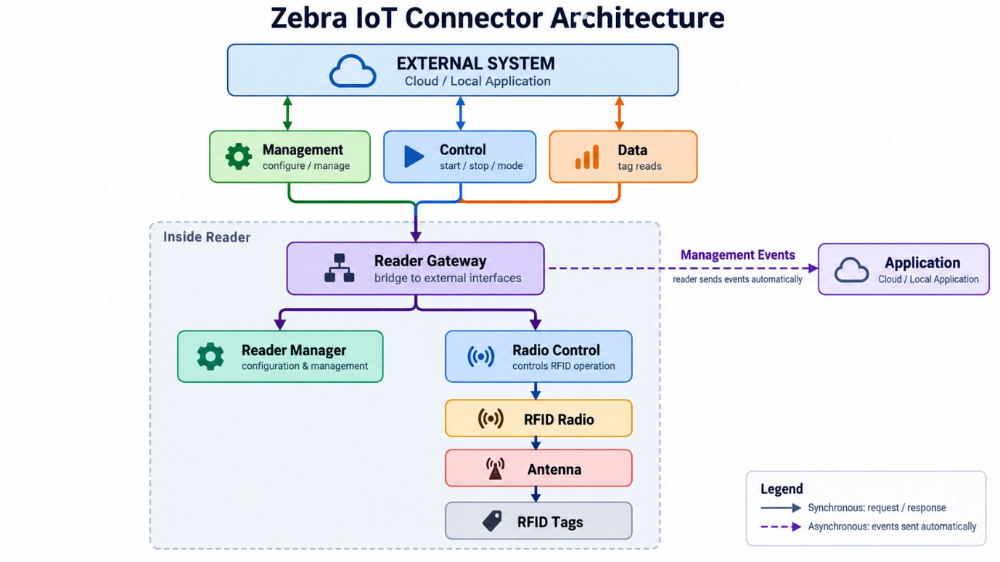
Sure. The main thing to understand is that deployment mode means: where each IoT Connector interface connects.
You already know the main interfaces:
Management
Control
Data
Management Events
Now deployment answers:
Do these interfaces connect to the cloud, stay inside the local network, or split between both?
Here is the easiest way to see it.
Deployment mode | Where interfaces connect
Pure Cloud | Everything goes to cloud services
Local | Everything stays inside the local network
Hybrid | Some go to cloud, some stay local

Pure Cloud Deployment
Scenario: your company wants to manage the FX9600 from AWS.
You may have:
FX9600
│
├── Management ─────→ AWS
├── Control ─────────→ AWS
├── Data ────────────→ AWS
└── Management Events → AWS
Suppose a carton passes the reader.
RFID Tag
↓
FX9600
↓
Data Interface
↓
AWS IoT Core
↓
Warehouse Cloud Application
And your cloud application can also send:
Start reading
Stop reading
Change configuration
back to the reader.
So Pure Cloud means:
The cloud is the main place where the reader is managed, controlled, monitored, and where tag data is received.
AWS IoT Core and Azure IoT Hub are examples of this model.

Local Deployment
Now imagine the customer does not want the reader communicating over the Internet.
Everything runs inside the warehouse network.
For example:
Warehouse Local Network

FX9600
│
├── Management ─→ Local server
├── Control ─────→ Local server
├── Data ────────→ Local server
└── Events ──────→ Local server
The reader can still communicate using technologies such as:
MQTT
REST
HTTP/HTTPS
The difference is not the protocol.
The difference is where the endpoint lives.
For example:
FX9600
↓
Local MQTT Broker
↓
Warehouse Application
No cloud is required.

Local Deployment with MQTT
Imagine the warehouse already runs an MQTT broker.
Then you can configure:
FX9600
├── Management → MQTT Broker
├── Control → MQTT Broker
└── Data → MQTT Broker
Your application also connects to that broker.
So:
Application
↕
MQTT Broker
↕
FX9600
For example, the application publishes:
start inventory
The reader receives it.
Later the reader publishes:
Tag EPC = ABC123
Your application consumes it.
So MQTT becomes the messaging middleman.

Local Deployment with HTTP / REST
Now imagine the customer does not want MQTT.
Management and control can happen directly through REST APIs.
For example:
Local Application
↓
REST API
↓
FX9600
Your application might send something conceptually like:
PUT configuration
or:
START reading
Tag data can be pushed by the reader to a local HTTP server:
RFID Tag
↓
FX9600
↓
HTTP POST
↓
Local Web Server
So this combination may look like:
Management → REST
Control → REST
Data → HTTP POST

Mixed Local Deployment
This is important because the interfaces do not all have to use exactly the same protocol.
For example:
Management → REST
Control → REST
Data → MQTT
Everything is still local.
That is why I called it Mixed Local Deployment.
The important point is:
Local describes the location of the system, not one specific communication protocol.

Hybrid Deployment
Now imagine your company wants centralized cloud management, but tag data is very large and must stay inside the warehouse.
You can do this:
Cloud
↑
Management
Control

FX9600

↓
Data
↓
Local Warehouse Server
So:
Management → AWS
Control → AWS

Data → Local HTTP Server
This is Hybrid Deployment.
Some interfaces use cloud endpoints.
Others use local endpoints.
That is why it is called hybrid.
A practical reason could be:
Cloud:
central reader administration

Local:
high-volume RFID tag processing

Why do we need "Choosing a Deployment Mode"?
Because users should not just see three architectures. They need to know which one fits their environment.
For example:
Choose Pure Cloud
when:
- cloud connectivity is available
- centralized remote management is wanted
- cloud applications consume RFID data
Choose Local
when:
- Internet access is unavailable or restricted
- data should remain inside the site
- local applications consume RFID data
Choose Hybrid
when:
- cloud management is useful
- but some data/services must remain local
So the whole deployment chapter is really answering one question:
Where should Management, Control, Data, and Management Events go?
And the three answers are:
Pure Cloud
All → Cloud

Local
All → Local network

Hybrid
Some → Cloud
Some → Local
That is the core concept you need before writing the deployment section of the guide.
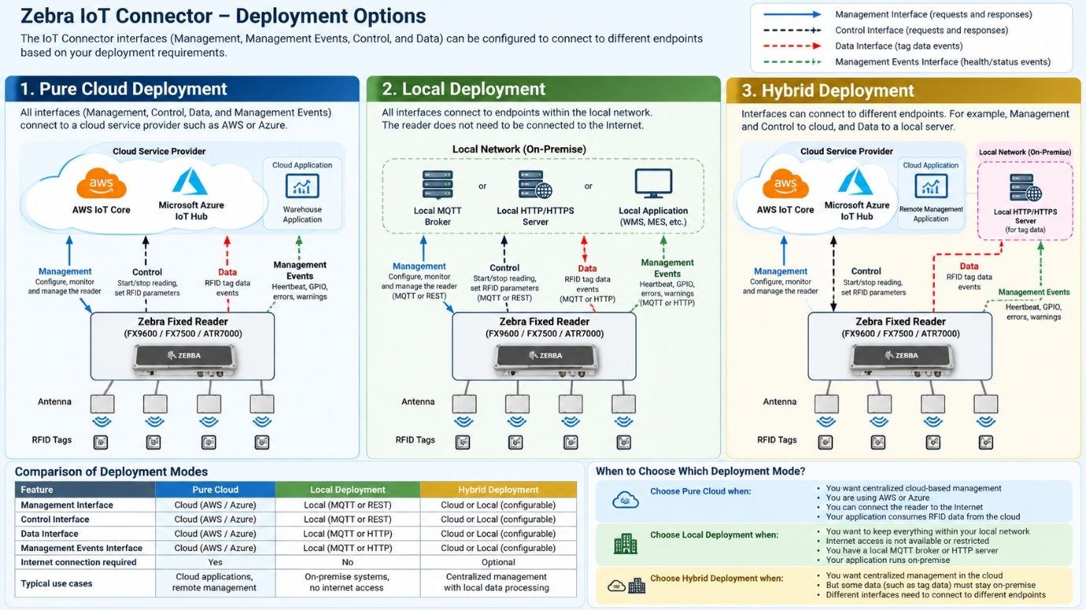
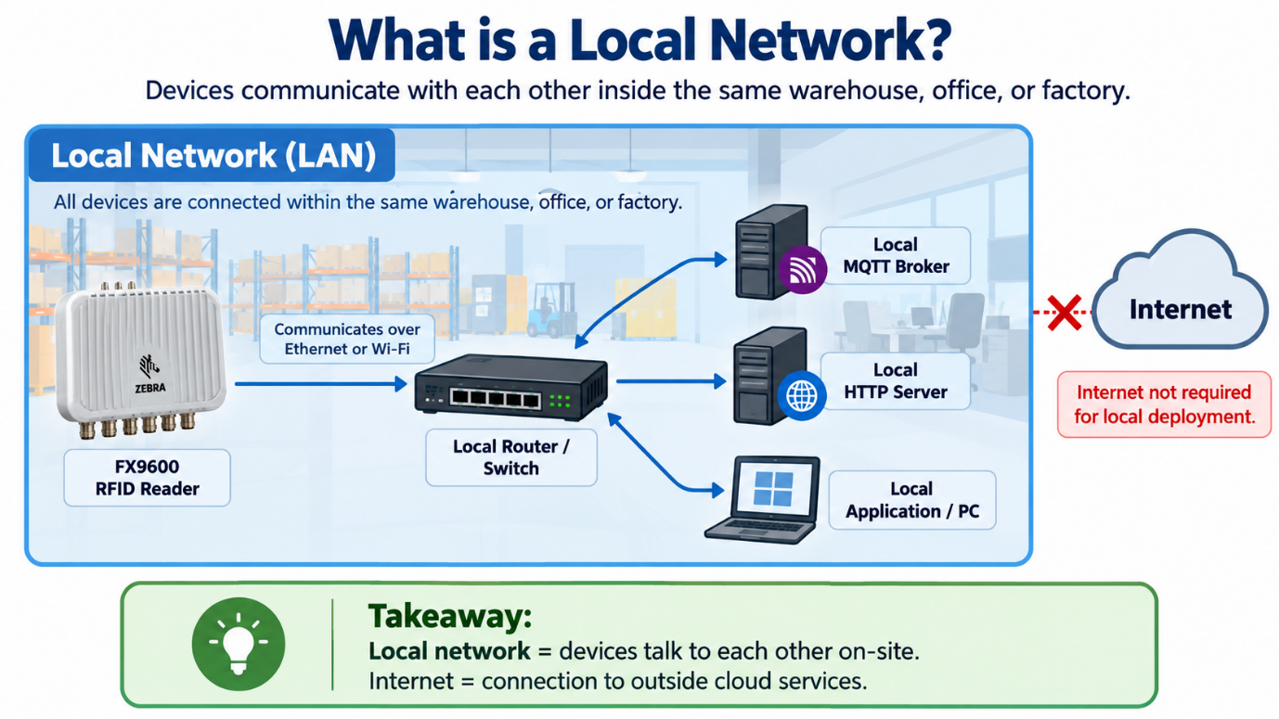
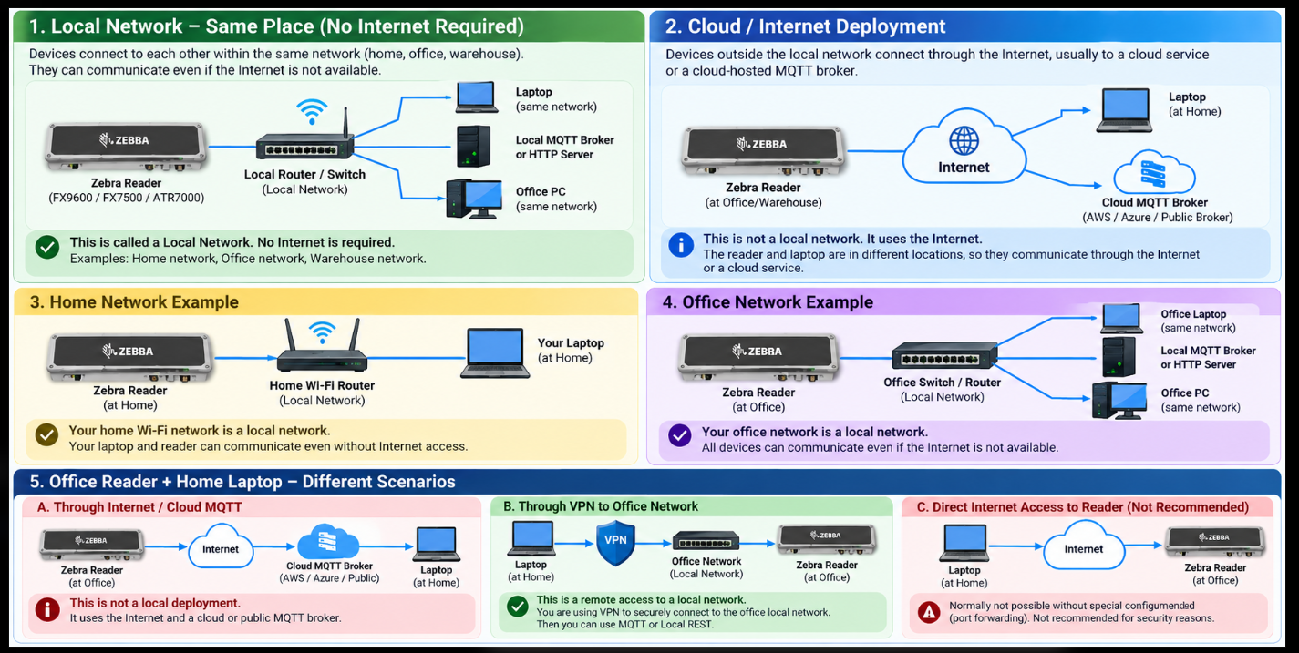

Sure. The easiest way is to understand this as one setup journey.
Imagine you have an FX9600 reader and you want this result:
RFID Tag
↓
FX9600
↓
IoT Connector
↓
MQTT / HTTP
↓
Your application
To make that happen, the setup has a few clear stages.

1. Configuration Overview
This is the high-level process.
You first tell the reader:
Where can I send data?
↓
Create endpoint

Which interface should use that endpoint?
↓
Assign interface

Now activate the setup
↓
Start IoT Connector
So the three steps are:
1. Add endpoint
2. Assign interface to endpoint
3. Start IoT Connector
That is the core workflow.

2. Access IoT Connector Configuration
Before configuring anything, you need to open the reader's configuration page.
For example:
Laptop
↓
Browser
↓
Reader IP address
↓
Communication
↓
Zebra IoT Connector
↓
Configuration
This section answers:
Where do I configure IoT Connector?
You are not yet deciding MQTT or HTTP. You are just opening the correct UI.

3. Configure Endpoints
This is very important.
An endpoint means destination.
Think:
Where should the reader connect or send information?
Examples:
MQTT Broker
HTTP Server
AWS IoT Core
Azure IoT Hub
Suppose you want tag data to go to an HTTP server.
You create:
Endpoint Name: webhook
Endpoint Type: HTTP POST
URL: https://example-server
Now the reader knows:
“This destination exists.”
But it still does not know what information should go there.
That comes in the next step.

4. Configure Interfaces
An interface means type of communication or purpose.
You already learned these:
Management
Control
Management Events
Tag Data
Now you connect an interface to an endpoint.
Example:
MQTT endpoint: mosquitto
↑
├── Management
├── Control
└── Management Events
And:
HTTP endpoint: webhook
↑
└── Tag Data
So the easiest way to remember is:
Interface = WHAT
Endpoint = WHERE
Example:
WHAT?
Tag Data

WHERE?
HTTP Server
Therefore:
Tag Data Interface
↓
HTTP Endpoint
↓
HTTP Server

5. Verify Interface Connection Status
After assigning the interfaces, you need to check whether the connection actually worked.
For example:
Management → Connected
Control → Connected
Tag Data → Connected
Or perhaps:
Tag Data → Connection failed
This answers:
Did the reader successfully connect to the configured destination?
So this is not configuration anymore. It is verification.

6. Start IoT Connector
After configuration is ready, you start the service.
Think of it like configuring a machine and then switching it on.
Endpoint configured
↓
Interfaces assigned
↓
Connection verified
↓
Start IoT Connector
Now the communication system becomes active.
One important distinction:
Start IoT Connector
≠
Start RFID tag reading
Starting IoT Connector means:
Enable the communication/service.
Starting RFID reading means:
Tell the RFID radio to begin scanning tags.
They are related, but not the same action.

7. Start RFID Reading
Once the IoT Connector is running, you can tell the reader:
START READING
For example through:
Web UI
or:
REST API
PUT /cloud/start
or:
MQTT control command
The internal flow is roughly:
Application
↓
Control Interface
↓
Reader Gateway
↓
Radio Control
↓
RFID Radio
↓
Antenna
↓
RFID Tags
Now tag reading begins.

8. Test with MQTT Client
Suppose you configured MQTT.
How do you know MQTT communication is working?
You use an MQTT client such as MQTTX.
The flow is:
FX9600
↓
MQTT Broker
↑
MQTTX
MQTTX connects to the same broker and subscribes to the configured topics.
Then you can see things such as:
Heartbeat
Reader status
Warnings
Management events
So MQTTX is mainly a test client here.
It is not part of IoT Connector itself.

9. Send Commands Through MQTT
Once MQTT communication is working, the MQTT client can also publish commands.
For example:
MQTTX
↓
Command topic
↓
MQTT Broker
↓
FX9600
Command:
start
Then the reader begins tag reading.
So now you have tested both directions:
Application → Reader
commands
and:
Reader → Application
events/data

10. Verify Tag Data
Finally, a tag passes in front of the antenna.
RFID Tag
↓
Antenna
↓
RFID Radio
↓
Reader
↓
Tag Data Interface
↓
Configured endpoint
If Tag Data was assigned to HTTP:
FX9600
↓
HTTP POST
↓
Webhook / HTTP Server
If Tag Data was assigned to MQTT:
FX9600
↓
MQTT Broker
↓
Application
Now you know the complete configuration is working.
So the full journey is:
Open IoT Connector UI
↓
Create endpoint
WHERE should communication go?
↓
Assign interfaces
WHAT should go there?
↓
Check connection
Did it connect?
↓
Start IoT Connector
Enable communication
↓
Start RFID Reading
Begin scanning tags
↓
Test MQTT / REST
Can I control and monitor it?
↓
Verify Tag Data
Did the data reach my destination?
That is why the IA separates these topics. Each section answers a different user question.
